**Bernard C. “Jack” Young**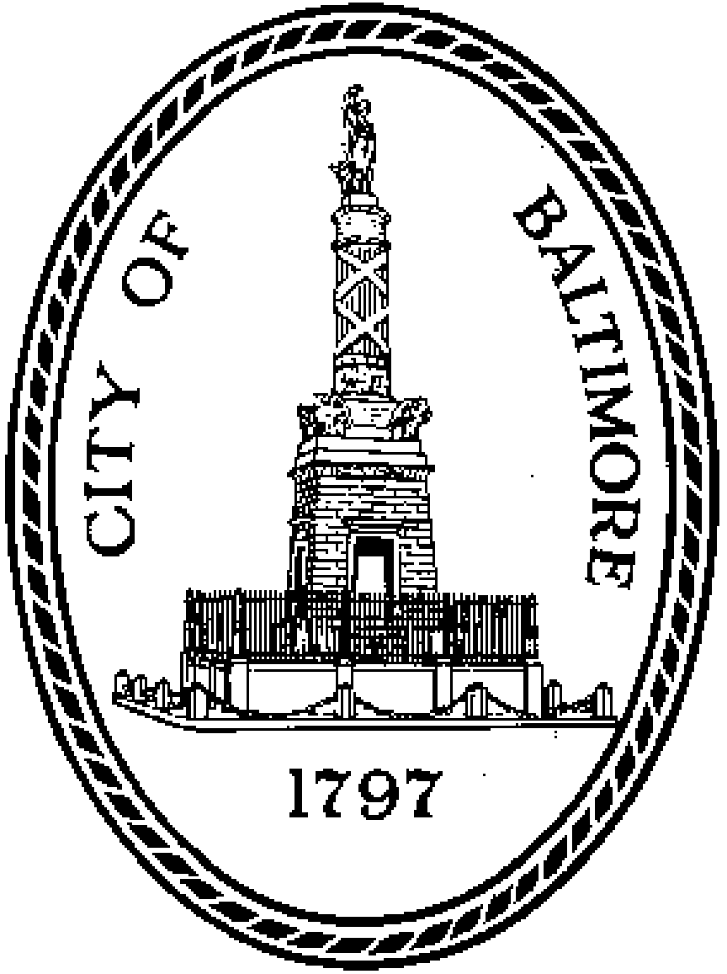

*Council President*

Baltimore City



100 Holliday Street, Room 400 Baltimore, MD 21202

Office: 410-396-4805 | Fax: 140-839-0647

**Subject |** Fines and Fees (IPA) – Interview Template

Interviewees | XXX

Organization | YYYY

Date | XXXX



Introductions:

We are a team of Masters of Public Policy students from the Goldman School of Public Policy, working with Kimberly Rubens, the Fiscal and Legislative Analyst for the City Council, to better understand the current state of fines and fees in Baltimore. Specifically, we want to measure the burden that fines and fees place on Baltimore residents as well as better understand the history of fines and fees in the city and the fiscal role they play in Baltimore.

We appreciate the chance to speak with you to understand how you- and the members of the communities you serve - interact with fines and fees in Baltimore. We view this interview as a major part of our information gathering efforts, and appreciate your help.

Note: The multiple parts of question 1 are meant to determine which line of questions are relevant to the specific department. If a department answers yes to any of questions 1A - 1E, then the following questions with that letter should be asked.

**Question 1:** How does your organization interact with fines or fees?

1. What fines or fees are targeted in your policy advocacy work?

*Question A2:* What are your organization’s priorities? How have these shifted over time?

*Question A3:* Does your organization advocate for certain policies in relation to fines or fees?

*Question A4:* How have you seen Baltimore residents respond to these fines or fees?

*Question A5:* Do you collect data on the impact of fines and fees on residents, and would you be willing to share that data with us?

1. Who has the ability to modify a fine or fee (set the price)?

*Question B1:* Which jurisdictions have authority over which specific criminal fines and fees? Civil fines and fees?

*Question B2:* What is the de facto protocol for modifying fines and fees (i.e. what is the process for changing the price)?

*Question B3:* What other community or government stakeholders are involved in that discussion?

*Question B4:* Can you walk us through a prominent example of a community stakeholder influencing an alteration in recent years?

1. Does your organization monitor activities related to and impacts of fines and fees (budget / criminal justice, etc…)

*Question C1:* What observations have you made looking at the effects of fines and fees on the budget / on individuals’ interactions with the criminal justice system?

*Question C2:* What observations have you made looking at the effects of fines and fees on families and communities?

*Question C3:* Has the role of fines and fees changed over time? Has the impact of fines and fees changed over time?

*Question C4:* What demographic trends has your organization observed in regard to fines and fees?

* How do these trends differ when criminal fines and fees are distinguished from civil fines and fees?

*Question C5:* How do fines and fees influence behavior?

1. How have fines and fees been reformed over the years?

*Question D1:* What have been your organization’s successes over the last five years?

*Question D2:* Have you seen anypromising solutions that address the negative consequences of fines and fees?

*Question D3:* What political constraints might impact implementation of these solutions?

*Question D4:* How have you partnered with Baltimore City in the past?

* What has worked well? What are the areas where the partnership could work better?

*Question D5:* What would you like to share with policymakers about fines and fees?

1. Are there fines and fees outside of your scope that affect your beneficiaries?

*Question E1:* What level of government do these fines or fees come from (federal, state, county, other city department)?

*Question E2:* What fines and fees specifically are they, and do you know of any other organizations that target their advocacy efforts toward them?

*Question E3:* What are the impact of these fees and have you seen any efforts to mitigate these impacts?

**Question 2:** What conversations have you had internally regarding modifications that you would like to see within the system of fines and fees that affects Baltimore residents?

**Question 3:** What conversations have you had or have you witnessed externally (i.e. in other parts of the government or with citizens or non-profit groups) on issues related to fines and fees, and have any changes emerged from these discussions?

**Question 4:** How are the fines and fees perceived by the community? Which fines and fees are perceived as the most burdensome? Least burdensome?

**Question 5:** What do you view as the purpose of fines and fees, and do you think they accomplish that purpose?

**Question 6:** Do you have any personal stories/case studies of Baltimore residents affected by fines and fees that you would be willing and able to share with us?

**Question 7:** Is there anything that I haven’t asked that I should know about fines and fees?

**Question 8:** Thank you for your time. If we have any additional questions, can we reach back out to you?